**Image processing HW3 Name:武敬祥 ID:b06611032**

# GUI

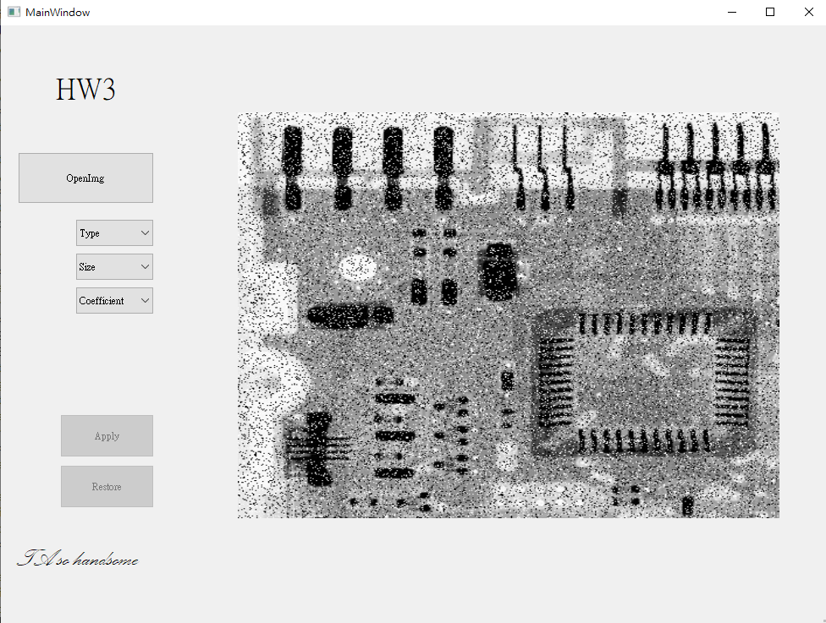

We can decide the type and size of a mask by “Type” and “Size” menu and create a bias when we choose “Coefficient” that is not equal to 1. The “Restore” button can restore to the original image. Only if we choose our “Type”, “Size” and “Coefficient” will the “Apply” and “Restore” button be functional.

# Part 1

## 3.22

### (a)

Yes

### (b)

$$w_{1}=\left[\begin{aligned}1 \\ 2\end{aligned}\right] , w_{2}=\left[\begin{matrix}1 & 3 & 1\end{matrix}\right]$$

## 3.27

An image is filtered four times using a Gaussian kernel of size 3 × 3 with a standard deviation of 1.0. Because of the associative property of convolution, we know that equivalent results can be obtained using a single Gaussian kernel formed by convolving the individual kernels.

### size of the single Gaussian kernel?

$$size=num*\left(n-1\right)+m$$

num = 3

m = 3

n = 3

$$size=3*\left(3-1\right)+3=9$$

### What is its standard deviation?

According to page 169 of textbook

$$σ_{f⋆g}=\sqrt{{σ_{f}}^{2}+{σ_{g}}^{2}}$$

As a result, the standard deviation is

$$σ_{1⋆2⋆3⋆4}=\sqrt{{σ_{1}}^{2}+{σ_{2}}^{2}+{σ_{3}}^{2}+{σ_{4}}^{2}}=\sqrt{1+1+1+1}=2$$

## 3.38

No, there wouldn’t be any change if we switch the operation order of these two mask. These is because of the commutative and associative property of convolution. We can easily check the result by the following example

$$w_{1}⋆w_{2}⋆M=(w_{1}⋆w_{2})⋆M=(w_{2}⋆w_{1})⋆M$$

The left equation is affected by associative property, and the right equation is governed by the commutative property.

## 4.3

## 4.32

Odd function : $f\left(x\right)=-f(n-x)$

Even function : $f\left(x\right)=f(n-x)$

1. {a, b, c, c, b}

The sequence is odd and

{0, 0, a, b, c, c, b, 0, 0}

1. {0, -b, -c, 0, c, b}

The sequence is odd and

{0, 0, 0, -b, -c, 0, c, b, 0, 0} also has oddness

1. {a, b, c, d, c, b}

The sequence is even and

{0, 0, a, b, c, d, c, b, 0, 0} also has evenness

1. {0, -b, -c, c, b}

The sequence is odd and

{0, 0, 0, -b, -c, c, b, 0, 0} also has oddness

# Part 2

## Original

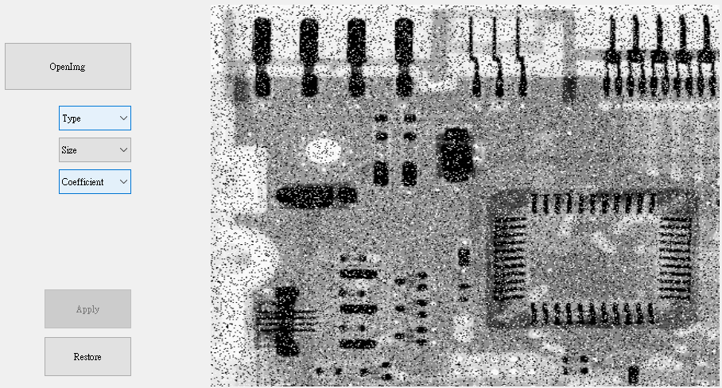

## 3*3

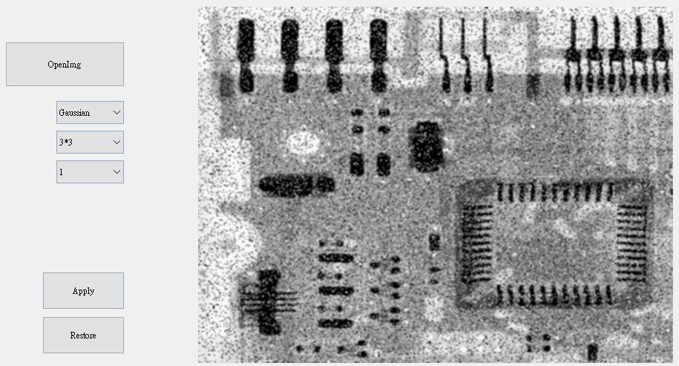

## 5*5

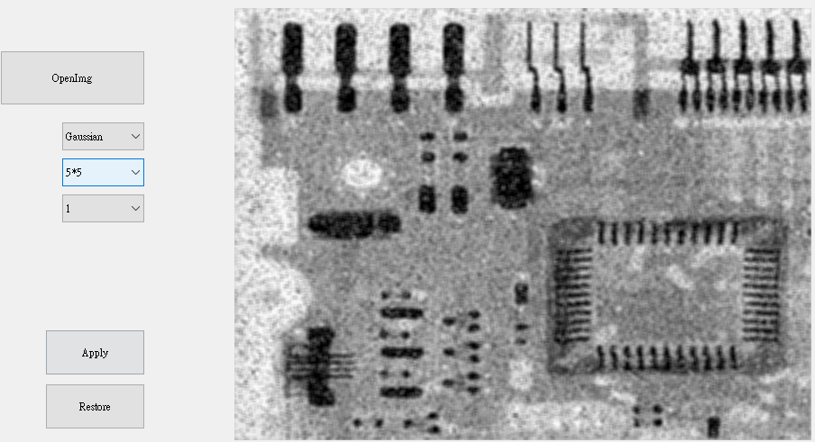

## 7*7

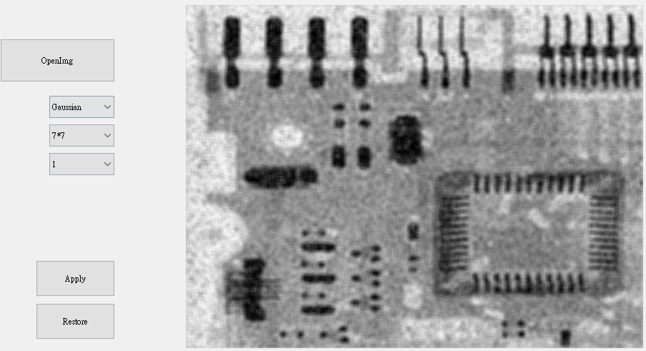

This is a comparation of different size of gaussian mask. When the mask size is larger, the image is blurrier, and the computation time is rising with the increasing of mask size.

# Part 3

## LoG Sobel

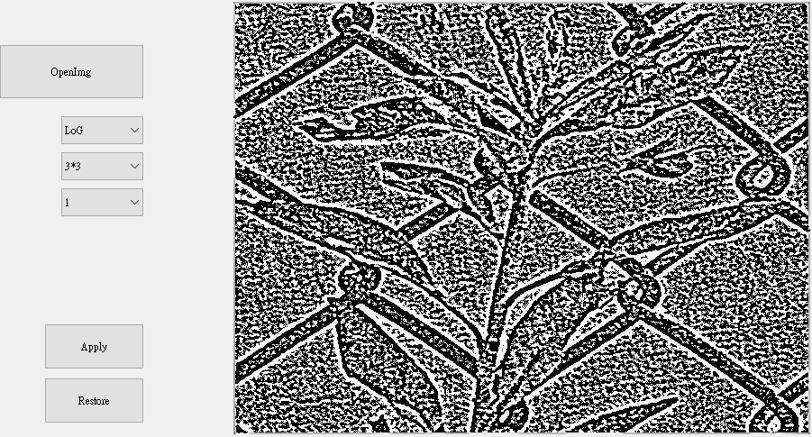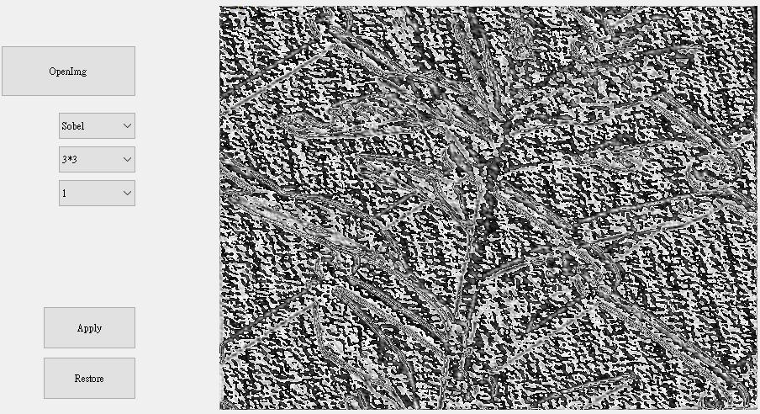

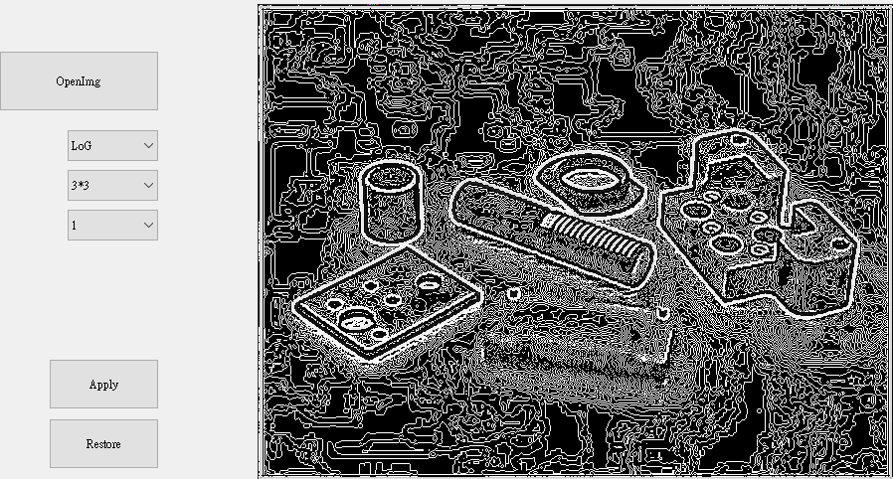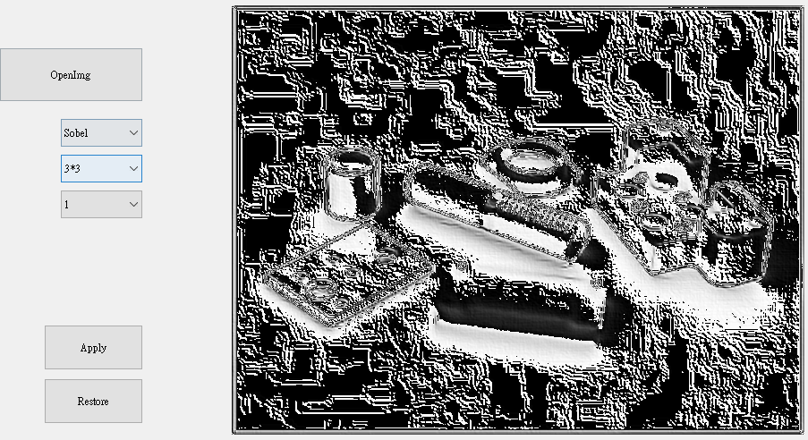

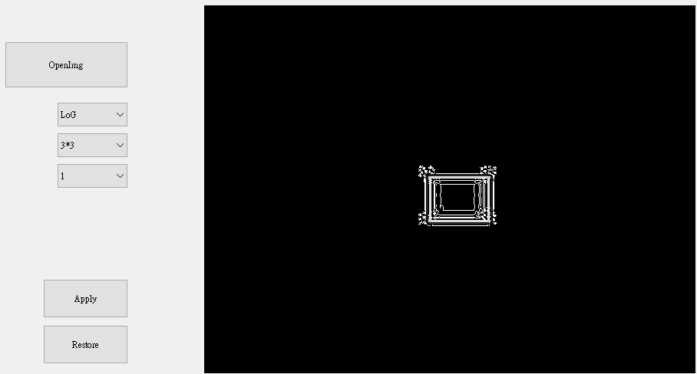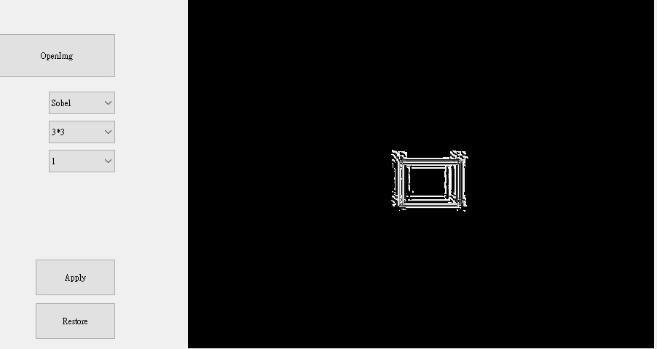

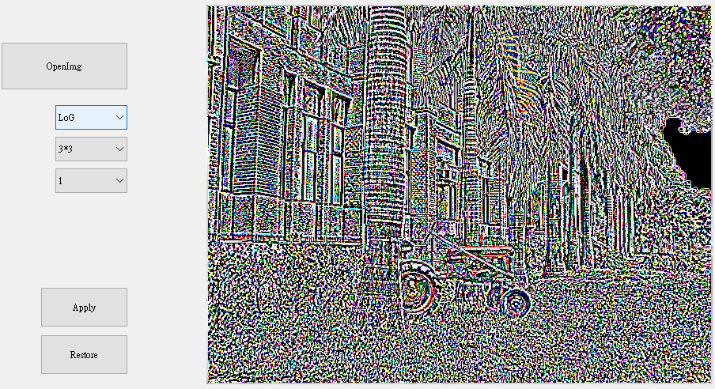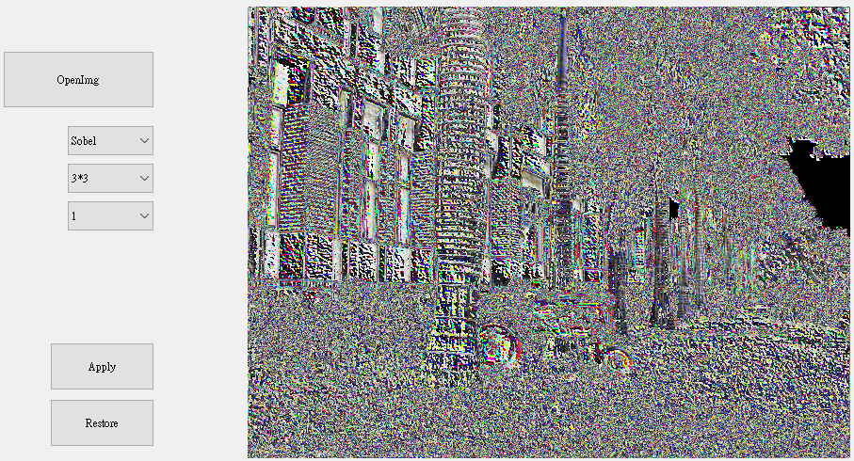

LoG filter has a better performance on detect the edge than Sobel operater in this case.

# Part 4

## Original

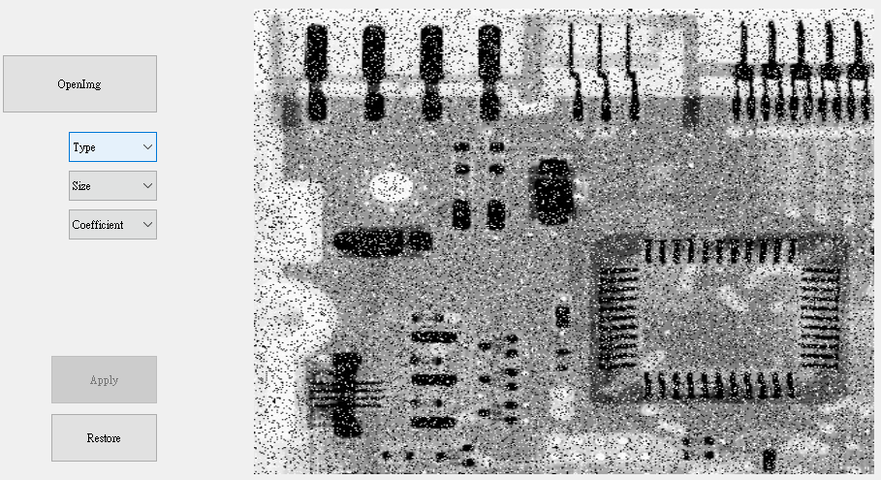

## Median filter with 5*5 mask size

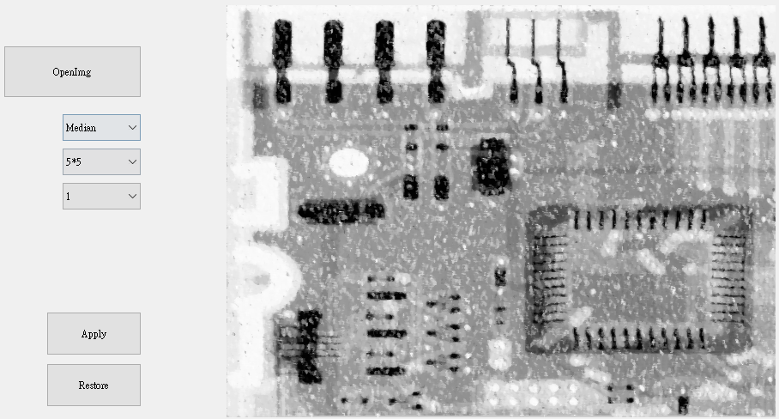

## Gaussian filter with 5*5 mask size

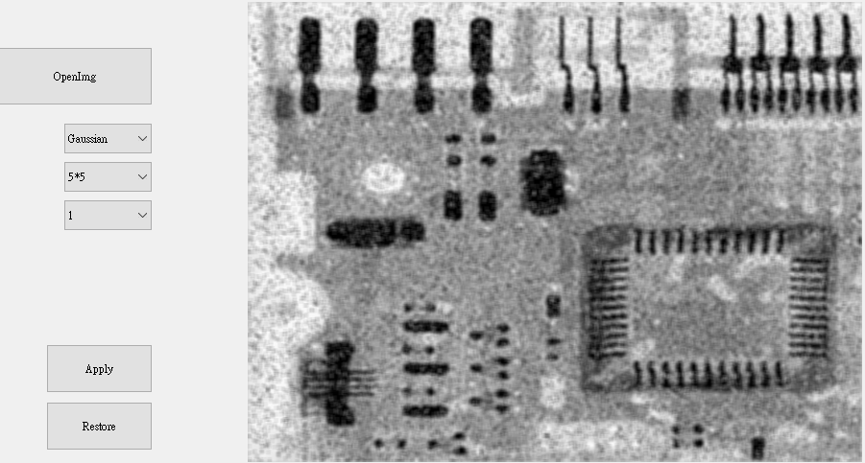

This is an image with pepper and salt noise. In this case, the median filter have more ability to eliminate these noises because pepper and salt noise indicate that there are many pixels with 0 and 255 in this image, and median filter can filter them. With comparison with median filter, the gaussian filter($σ=15$) can also eliminate the noises, however, gaussian filter will give weight to these noises so that it cannot effectively eliminate it. On the other hand, for both filters, the larger filter size will increase the performance of eliminating noises.